**AIM:** Design DFA using simulator to accept the string the end with abc over set {a,b,c) W= abbaababc

**INPUT:**

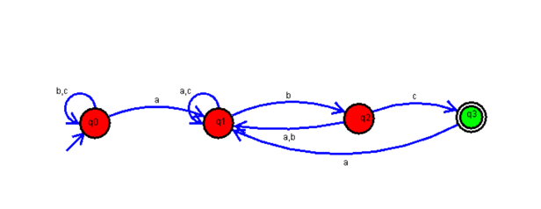

**OUTPUT:**

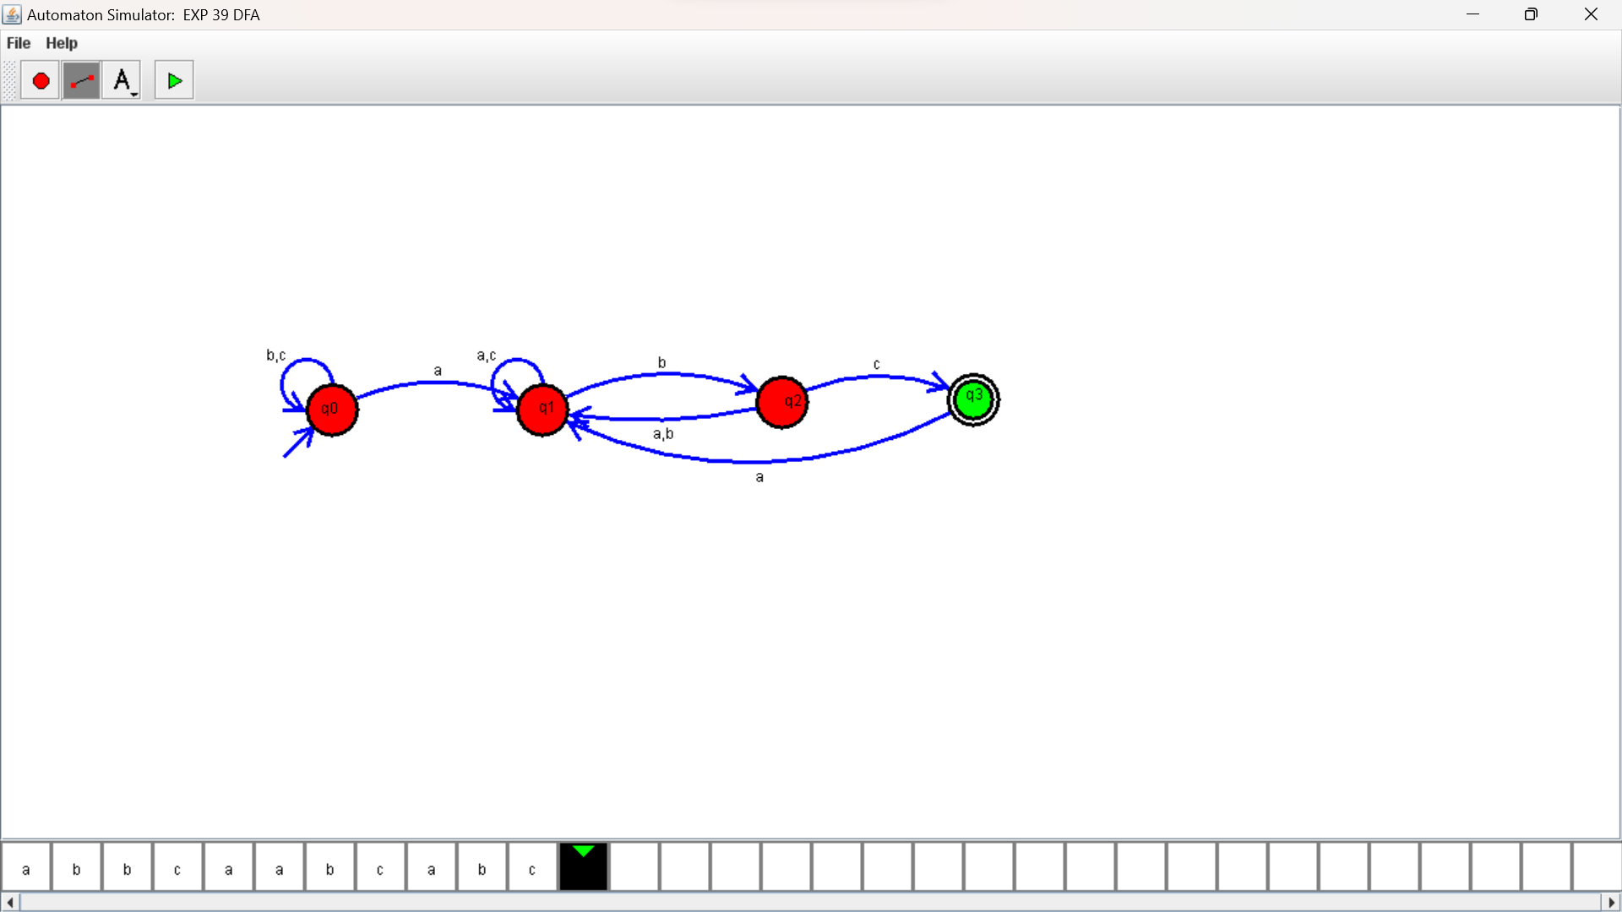

**RESULTS**:

DFA using simulator to accept the string the end with abc over set {a,b,c)

W= abbaababc